**Exporting Logs**

# B. Charles Sutton W1MCP, Jim Hargrave W5IFP and Aki Yoshida JA1NLX

## 1.0 GENERAL

Logger32 gives you the option to export your logs in three different formats. To export your log:

From the Logger32 Main menu select the Files | Export Logs menu items, then choose the output format of your choice.

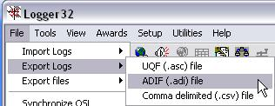

EL_1

Logger32 will prompt you for the filename you wish to receive your exported QSO records. You can choose an existing file (doing this will overwrite all data in that file), or you can create a new file.

## 2.0 OUTPUT FORMATS

### 2.1 ADIF

Logger32 follows all the standards for exporting ADIF files, here is an example of a portion of an ADIF record:

<CALL:5>KE1EH <QSO_DATE:8:D>20000402 <TIME_ON:6>000016 <MODE:3>SSB <BAND:3>10M <RST_SENT:2>59 <EOR>

After selecting the ADIF format the Export log dialog box will open with additional options:

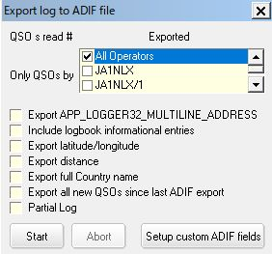

New EL_2

Select the appropriate operator(s) you wish to receive your exported QSO records, or choose "All Operators". Logger32 will allow you to select more than one operator.

**2.1.1 Include logbook informational entries**:

With this option checked, the export will include logbook entries, which were entered for information regarding propagation, SWL, etc.

**2.1.2 Export full Country name**:

If this option is checked - Logger32 will export an additional field with the full country name.

**2.1.3 Export Latitude/Longitude**:

With this option checked, Logger32 will export Latitude & Longitude data for each record using the <APP_LOGGER32_LAT:x> and <APP_LOGGER32_LNG:x> fields.

**2.1.4 Setup Personal ADIF fields.**

**2.1.4.1 Export These Fixed ADIF Fields:**

This option allows the operator to export ADIF fields or Personal defined fields. The fields must be in ADIF_FORMAT. The desired text can be in any format. Following is an example of using this feature. Each field entered will be appended to each record exported.

**Note**: Logger32 only supports the ADIF fields listed in the Logbook setup chart. Non-standard ADIF fields can be exported, but will be ignored upon import.

Some logging facilities, notably the logger in QRZ.com as one, may require the ADIF field, STATION_CALLSIGN as part of each record within the file.  This can be accomplished using a fixed field. This might also be useful for Field Day where all contacts are made under a single club callsign or special events where several operators participate using a club callsign.

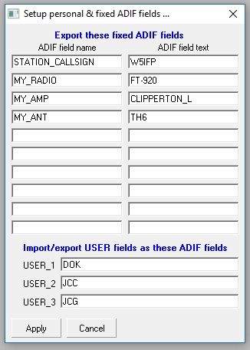

EL_2A

The following is an excerpt of the ADIF file using the above sample.

……. <STATION_CALLSIGN:5> W5IFP<MY_RADIO:6>FT-920 <MY_AMP:12>Clipperton L <MY_ANT:4>TH-6 <EOR>

**2.1.4.2 Import/Export USER Fields as These ADIF fields**

This option allows the operator to export/import USER fields as user defined ADIF fields. Following is an exported ADIF example of using this feature. USER field data are “a”, “b” and “c” for USER_1, USER_2 and USER_3 fields in this case.

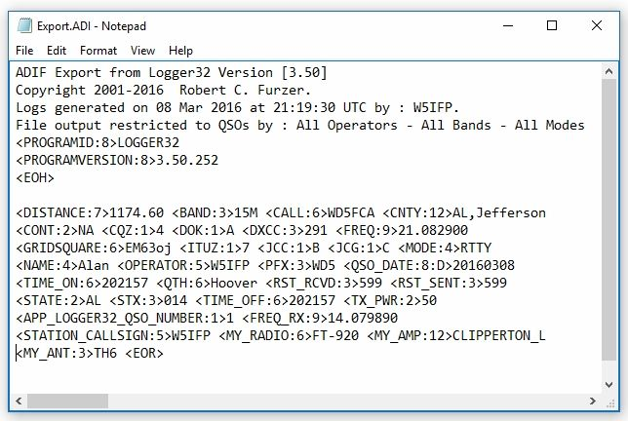

EL_2B

### 2.1.5 Export all new QSOs since last ADIF export

The option is intended for those who periodically export new QSOs from their logbook to send to QSL Managers, or wherever.  The option is disabled to start.  Export your logbook, add new QSO, now the option will allow you to export only the new QSO.

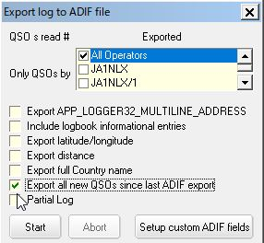

**New EL_2C**

**2.1.6 Partial Log**: See Below

When you click the <**Start**> button, Logger32 will begin exporting your QSOs. You can click the <**Abort**> button any time after this point to stop the export.

## 2.2 Comma Delimited (csv)

The first four lines of the CSV file have details about the data it contains, the sixth line shows the field headers, and the following lines contain the QSO records. Here is an example of a portion of a CSV record:

"KE1EH","RI,KENT","","NA","","03","","291","28.305000","","","06","","","SSB","Rusty"

CSV files can be easily imported into many other programs, including Microsoft Excel. You may have to delete the first four header lines to do so in some programs.

After selecting the CSV format, the Export log dialog box will open with additional options:

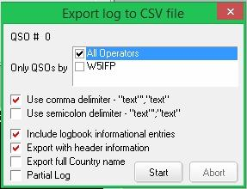

EL_3

Select the appropriate operator(s) you wish to export QSO records for, or choose "All Operators". Logger32 will allow you to select more than one operator.

**Include logbook informational entries**: With this option checked, the export will include logbook entries which were entered for information regarding propagation, SWL, etc.

**Export full Country name**: If this option is checked - Logger32 will export an additional field with the full country name.

**Export with header information**: With this option checked, Logger32 will export the data file wth field Header information.

**Partial Log**: See Below

When you click the <**Start**> button, Logger32 will begin exporting your QSOs. You can click the <**Abort**> button any time after this point to stop the export.

## 2.3 UQF (asc)

This format is for limited and specific use. Only select fields are exported from the Logbook; here is an example:

CA1LL 040901 0514 80 CW 599

After selecting the UQF format the Export Log dialog box will open with additional options:

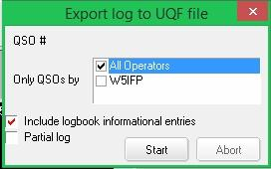

EL_4

Select the appropriate operator(s) you wish to export QSO records for, or choose "All Operators". Logger32 will allow you to select more than one operator.

**Include logbook informational entries**: With this option checked, the export will include logbook entries which were entered for information regarding propagation, SWL, etc.

**Partial Log**: See Below

When you click the <**Start**> button, Logger32 will begin exporting your QSOs. You can click the <**Abort**> button any time after this point to stop the export.

## 3.0. PARTIAL LOG

Selecting this option will expand the dialog boxes shown above providing additional options allowing a partial log export based on start and end dates, specific bands and specific modes, specific callsigns and country numbers, start QSO number and end QSO numbers.The band and mode options allow multiple selections. You should run “Reformat QSO number” when you use QSO number option.

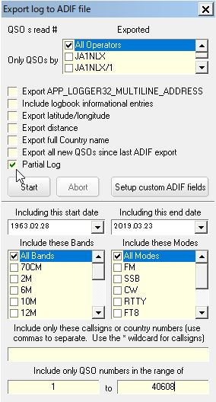

New EL_5

## 4.0 ADIF FIELD CHANGES

### 4.1 Country Field

Changes to the Country field in L32 version 3.x and up: Prior to the adoption of ADIF version 2, when you asked Logger32 to export the full country name, Logger32 would add an additional field named

APP_LOGGER32_COUNTRY. ADIF version 2 now allows for a full country name field, "COUNTRY", and Logger32 will now export the full country name into that field. Please be aware that if you have other software, such as a log printing program, that is expecting to find the APP_LOGGER32_COUNTRY field, you will need to change it to COUNTRY.

### 4.2 County (CNTY) Field

Changes to the CNTY field in L32 version 3.x and up: Logger32 allows the user considerable flexibility in setup/usage of the Primary/Secondary Admin Subdivisions. For ADIF 2.x compatibility, ADIF export/import of the CNTY field will apply to Countries that have ADIF defined Secondary Admin Subdivisions. Countries that have no ADIF defined Secondary Admin Subdivisions will be exported/Imported as APP_LOGGER32_CNTY.

### 4.3 State (STATE) Field

Changes to the STATE field in L32 version 3.x and up: STATE fields that are defined by ADIF (Primary Admin Subdivision) are exported/imported as <STATE:x> whereas others are exported/imported as APP_LOGGER32_STATE:x>

### 4.4 Mode and Sub Mode Field

When it exports mode,

a) if mode is ADIF MODE then ADIF MODE is written as <MODE>.

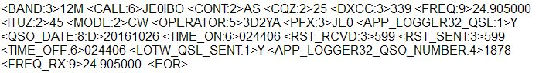

EL_6

b) If mode is ADIF SUBMODE then corresponding ADIF MODE is written as <MODE> and ADIF SUBMODE is written as <SUBMODE>

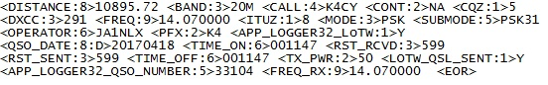

EL_7